Teacher Background Information for Introducing Histograms to Students

The following lessons and worksheets were designed to provide a basic format when introducing the concept of data collection and histograms (bar graphs of frequency) to students. The following are explanations to the lessons.

Histogram Worksheet –
This worksheet is designed to introduce the students to Histograms. It can be used at any time but may serve as a good spring board as to what a histogram is and how it is useful in data analysis.

Histograms and Distribution (hands on) –
This activity is designed as a hands-on demonstration of how ‘random’ distributions of paper punch-outs fall on a grid. Questions are posed to the student at the end of the activity and a teacher answer sheet is included to help facilitate the discussion.
Note: The activity is designed to be done in the classroom; however, a variation can be done outside on a football field with students throwing balls from each end zone toward center field

Histograms Lesson 1 –
This lesson takes ‘canned data’ from rolling a ball down a ramp and has the students determine groupings (bins), sorting the data into the bins and graphing by hand the results of the sorting. Questions are posed to the student at the end of the activity and a teacher answer sheet is included to help facilitate the discussion.

Histogram Lesson 2 (pre Question of Timing worksheet) –
This lesson is a reinforcement for Lesson 1 but now uses actual detector TOFs (time of flights) for the set of data and introduces the students to the nanosecond. The students must determine how they are going to bin the data and graph the results by hand. Because the data is already sorted in ascending order, they should easily recognize the trend of 0.75 intervals in the time values. Also the concept of ‘erroneous’/outlying data is introduced to the student. Questions are posed to the student at the end of the activity and a teacher answer sheet is included to help facilitate the discussion.

Enrichment Activities-based on Muon detectors

Question of Timing worksheet –
This worksheet is a non-detector approach to make students think about how timing events can become skewed due to the timing mechanism itself. It is designed to be used as an introduction to the calibration factor that is used when determining the speed of a muon and other experiments using the detectors.

Histogram lesson 3 (post Question of Timing worksheet)
This lesson contains actual data from using 2 detectors separated by a distance of 1.41m. The experiment was performed changing the position of the detectors, switching which detector was on top. At the time of the trial run, the computer was told which detector was on top, so when data was recorded for the second trial the data comes in as a negative value. The data is pre-sorted as separate trials. This lesson has the students use Excel and the Histogram feature for the first time. Students are also introduced on how to use Excel to determine the average TOFs for each trial. (This sets them up for the process needed to complete the Speed of the Muon lab). Questions are posed to the student at the end of the activity and a teacher answer sheet is included to help facilitate the discussion.

Speed of a Muon activity
The lab included can be used as is or changed based on your classroom focus. The distance of 1.4 meters is used because during our experimentation the detectors took in 40-50 valid (1,2) hits during a 10 minute interval. This provides for ‘real time’ recording of the events so that students will not have to transfer the data to a computer using a floppy disk or flash drive. If you do a full 10 minute (600 seconds) run, please remember that the detector positions need to be switched for an additional 10 minute run. Depending on your class time you can do two 5 minute runs instead and just acquire ½ the amount of data.

Histogram Worksheet

The 3 histograms below show the batting averages of the winners of the batting title in the major league baseball (for both the American & National leagues) for certain years in the 1900s. Batting average shows the percent (written as a decimal) of the time a certain player gets a hit. A player who has a batting average of 0.405 has gotten a hit in 40.5 % of the times that they were at bat. The batting title is an award given to the player with the highest batting average for a given season. Refer to the histograms as you answer questions 1 – 6.

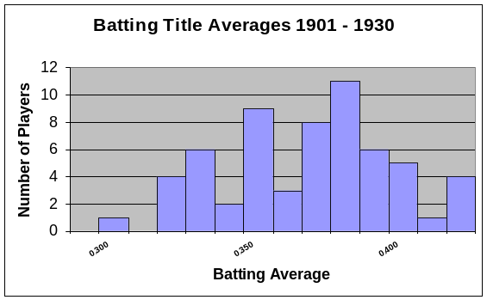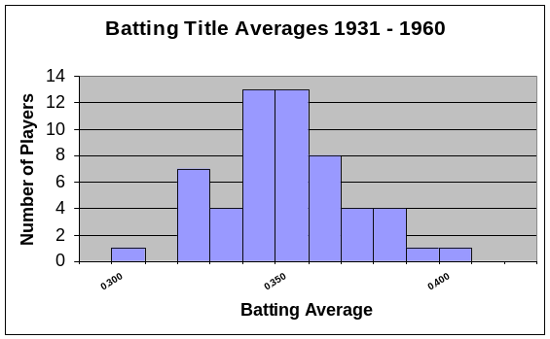

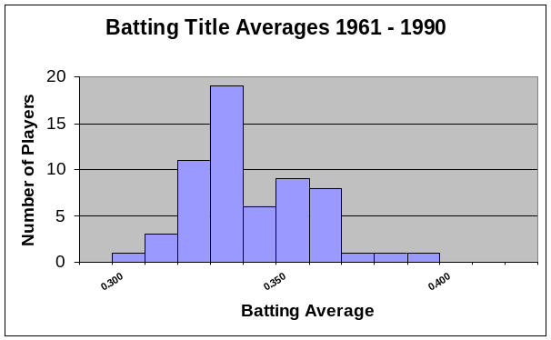

_________1. How many batting titles were won with a batting average of between 0.300 and 0.350 from 1901 to 1930?

_________2. How many batting titles were won with a batting average of between 0.300 and 0.350 from 1931 to 1960?

_________3. How many batting titles were won with a batting average of between 0.300 and 0.350 from 1961 to 1990?

4. If you were to find the mean of each of the winning batting averages for each time period, which time period do you think would have the highest mean? Explain.
____________________________________________________________________________________________________________________________________________________________________

5. As the century progressed, what in general happened to the batting averages of the batting title winners? Explain.
____________________________________________________________________________________________________________________________________________________________________
____________________________________________________________________________________________________________________________________________________________________

For questions 6 – 10, refer to the following 2 histograms. These histograms were made in an attempt to determine if William Shakespeare was really just a pen name for Sir Francis Bacon. (A pen name is a fake name used by another person when writing). A few scholars have had this idea and in order to determine if this was true, a researcher had to count the letters in every word of Shakespeare’s plays & Bacon’s writing (and you thought you had a lot of homework). Their results are recorded in the histograms below.

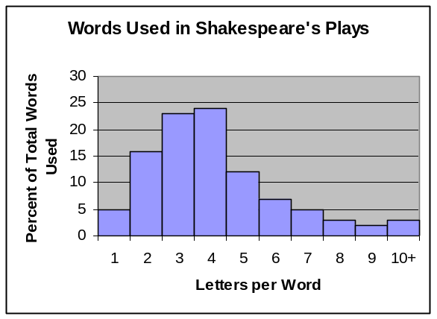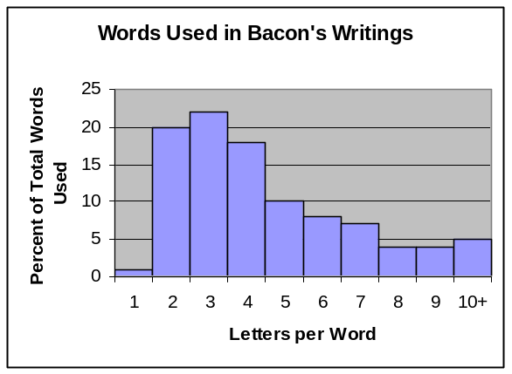

_________6. What percent of all Shakespeare’s words are 4 letters long?

_________7. What percent of all Bacon’s words are 4 letters long?

_________8. What percent of all Shakespeare’s words are more than 5 letters long?

_________9. What percent of all Bacon’s words are more than 5 letters long?

10. Based on these histograms, do you think that William Shakespeare was really just a pen name for Sir Francis Bacon? Explain.
_____________________________________________________________________________________________________________________________________________________________________________________________________________________

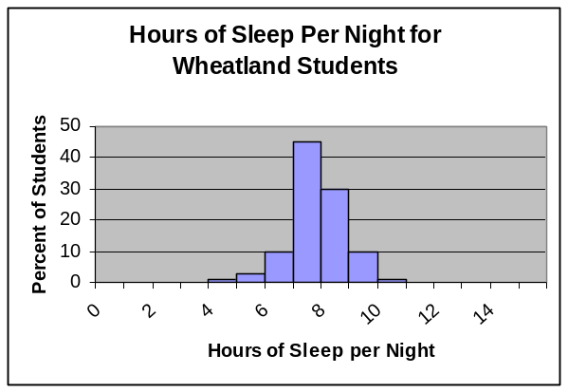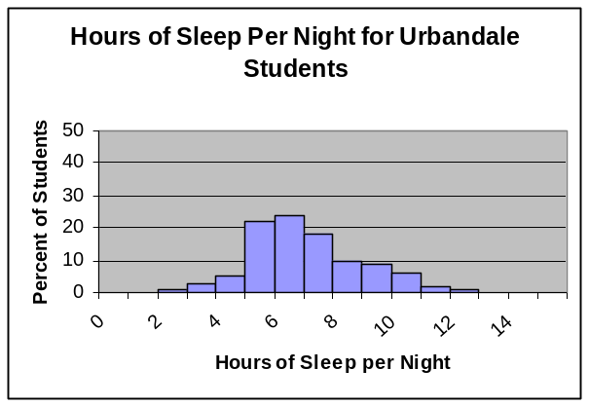

Suppose that the two histograms above show the sleeping habits of the teens at two different high schools. Wheatland High School is a small rural school consisting of 100 students while Urbandale High School is located in a large city and has 3,500 students.

_________11. About what percent of the students at Wheatland get at least 8 hours of sleep per night?

_________12. About what percent of the students at Urbandale get at least 8 hours of sleep per night?

_________13. Which high school has more actual students that sleep between 9 – 10 hours per night?

_________14. Which high school has a higher median sleep time?

15. Wheatland’s percent of students who sleep between 8-9 hours a night is ________ % more than Urbandale’s percent of students who sleep between 8-9 hours per night.

16. Consider the type of data in the last two sets of problems (letters per word & sleep times).

_________a) Are letters per word qualitative or quantitative?

_________b) Are sleep times qualitative or quantitative?

_________c) Which data set is continuous?

_________d) Which data set is discrete

- The charts below shows the age of the actress & actor who won the Oscar for best actress or actor during the first 30 years of the Academy Awards. Use the charts to make two histograms (one for winning actresses ages & one for winning actors ages) displaying this information. Use bin widths of ten years (0-9; 10-19; 20-29 etc.)

Year | Age of Winning Actress | Age of Winning Actor
1928 | 22 | 42
1929 | 36 | 40
1930 | 28 | 62
1931 | 62 | 53
1932 | 32 | 35
1933 | 24 | 34
1934 | 29 | 33
1935 | 27 | 52
1936 | 27 | 41
1937 | 28 | 37
1938 | 30 | 38
1939 | 26 | 34
1940 | 29 | 32
1941 | 24 | 40
1942 | 34 | 43
Year | Age of Winning Actress | Age of Winning Actor
1943 | 24 | 49
1944 | 29 | 41
1945 | 37 | 40
1946 | 30 | 49
1947 | 34 | 56
1948 | 34 | 41
1949 | 33 | 38
1950 | 28 | 38
1951 | 38 | 52
1952 | 45 | 51
1953 | 24 | 35
1954 | 26 | 30
1955 | 47 | 38
1956 | 41 | 41
1957 | 27 | 43

18. Write a short paragraph discussing what your two histograms reveal.

______________________________________________________________________________________________________________________________________________________________________________________________________________________________________________________________________________________________________________________________________________________________________________________________________________________________________________________________________________________________________________________________________________________________________________________________

Histograms and Distribution Activity Name __________________________

Materials:
- Football field pre-copied onto a large piece of paper.
- Handful of paper disks from a 3-hole punch apparatus
- Graph paper (or access to a computer)

(-) |  |  |  |  |  |  |  |  |  |  | (+)
E |  |  |  |  |  |  |  |  |  |  | E
N |  |  |  |  |  |  |  |  |  |  | N
D |  |  |  |  |  |  |  |  |  |  | D
 | -(0-10) | -(10-20) | -(21-30) | -(31-40) | -(41-50) | 50-41 | 40 - 31 | 30 - 21 | 20 - 11 | 10 - 0
Z |  |  |  |  |  |  |  |  |  |  | Z
O -55 | -45 | -35 | -25 | -15 | -5 | 5 | 15 | 25 | 35 | 45 | To O
N |  |  |  |  |  |  |  |  |  |  | N
E |  |  |  |  |  |  |  |  |  |  | E

Pre-Activity questions:
- When you drop the paper disk, if it falls on the line between 2 zones, how will you decide which zone to count it in? _____________________________________________________
_______________________________________________________________________________________________________________________________________________________
- Why are the zone values on the left recorded as negative? ____________________________
___________________________________________________________________________
___________________________________________________________________________
- When you create the histogram of your data, what values will you place on the
x-axis? _________________________On the y-axis?______________________

Procedure:
- Take a handful of paper punch-outs; hold them approximately 40 cm above the middle of the field. Have a partner check to see that you are not skewed toward either side of the 50 yard line.
- Drop the paper punch-outs onto the field.
- Create a chart to record the data for the number of paper pieces that fell into each zone. Record each zone using the bottom set of numbers. This represents the average distance from the center, 50 yard line.
- From your chart, graph the data as a histogram.
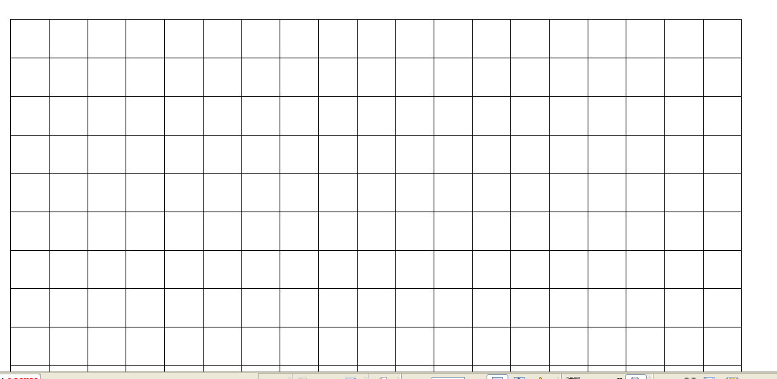

Analysis questions
- Draw the general shape of your histogram as a line graph:

- Does the line graph have a characteristic shape? _________
- If so, what is the general shape of this graph?___________________________________________
- Explain why you think the graph is shaped this way: _____________________________
________________________________________________________________________
________________________________________________________________________

- Were there any ‘outlying’ values on your graph (beyond the general graph pattern or off the field)? _____________ If so, explain if these data points should be discarded: ____________________________________________________________________________________________________________________________________________________________________________________________________________________________________

- Brainstorm some ideas as to why some of the paper disks fell so much farther from the 50 yard line then others:
  - ____________________________________________________________
  - ____________________________________________________________
  - ____________________________________________________________
  - ____________________________________________________________
  - ____________________________________________________________

- How would the following scenarios affect the results of your histogram:
Height of the drop - ____________________________________________
_____________________________________________________________
_____________________________________________________________

Location of the drop in reference to the 50 yard line - __________________
_____________________________________________________________
_____________________________________________________________

Throwing the disks onto the field instead of dropping them - _____________
______________________________________________________________
______________________________________________________________

- How can viewing a histogram be used to reconstruct the ‘history’ of the event that occurred?
______________________________________________________________
______________________________________________________________
______________________________________________________________
______________________________________________________________

Teacher answer sheet
Pre-Activity answers
- The ‘bins’ representing the grouping of the yard lines on the field is on the x-axis and the ‘frequency’ or ‘number of events’ is on the y-axis
- The zones to the left of the 50 yard line are negative because of the need to address the directionality based on the location of the areas to right and left of the 50 yard line. The left was arbitrarily determined to be the negative values.
- The graph should have the look of a Gaussian, bell-shaped curve.

- The outlying data points are erroneous and can be deleted from analysis because they are outlying values.
- and 4. There are several reasons why some of the paper disks fell so far from the 50 yard line and this makes for good discussion. Possibilities include - air current, incomplete disk size, location in the hand, random effect….The affects of the height, location and throwing create histograms that may have larger bins or bins that are shifted to the right or to the left.
5. A histogram shows the possible origin, velocity, implications of how the event occurred.

Sample Data

paper drop
0
20
40
60
80
100
120
-55
-45
-35
-25
-15
-5
5
15
25
35
45
55
Average dist from 50 yard line
# paper disks
Series1
 | # paper disks | midpoint of event location | total number
 | 3 | -55 | -165
 | 6 | -45 | -270
 | 13 | -35 | -455
 | 19 | -25 | -475
 | 38 | -15 | -570
 | 96 | -5 | -480
 | 82 | 5 | 410
 | 33 | 15 | 495
 | 16 | 25 | 400
 | 7 | 35 | 245
 | 8 | 45 | 360
 | 1 | 55 | 55
Total disks | 322
avg distance from 50 |  |  | -1.40

Note: average distance from 50 is determined by adding up the total number columns and dividing that value by the total disks (322). This average distance value gives you the ‘skew’ of the data from the center point.

Note: If advanced data analysis is wanted (standard deviation) – please go to the Finding Muon Speed activity-Advanced Level Analysis section for instructions using excel.

Histograms – Lesson 1 Name ________________________
While performing a routine experiment, students gathered data for the time required for a ball to roll down a 1 meter ramp at a 30 degree angle. The following data was collected:
trial | time (sec) |  | time range (sec) | # of values
1 | 0.316
2 | 0.324
3 | 0.325
4 | 0.316
5 | 0.309
6 | 0.316
7 | 0.311
8 | 0.312
9 | 0.317
10 | 0.308
11 | 0.311
12 | 0.399
13 | 0.313
14 | 0.314
15 | 0.314
16 | 0.242
17 | 0.321
18 | 0.316
19 | 0.309
20 | 0.317

- To determine the range of values for the chart determine the highest and lowest values for time. Highest ________________Lowest_________________
- Take the difference in the highest and lowest values and divide the difference into ___________ ranges (known as bins)
- Use the data to complete the chart to the right, categorizing each time value into its proper range.
- On the graph paper, label the x-axis as time (seconds) and the y-axis as frequency.
- For each time range shade in the number of boxes (frequency) that correspond to the number of events that occurred within that range.

Analysis questions
- What do you notice about the graphed results of the histogram?

- Note the outlying data points. Are these valid points or should they be disregarded? Why or why not?

3. What is binning?

4. What is on the y-axis of any histogram graph?

5. What is a histogram?

6. How is a histogram used to determine valid/invalid data?

7. Based on the histogram, what is the time for the ball to roll down the ramp?

8. Based on the histogram, what is the reasonable range of uncertainty in the time?

Teacher answer sheet - Histograms – Lesson 1
- The data is grouped so that the most frequent values are a distinguishing peak on the graph.
- The outlying data points are erroneous and can be deleted from the analysis of the the values.
- Binning is a method of sorting data by clustering similar values and determining frequency.
- The ‘frequency’ or ‘number of events’ is on the y-axis.
- A histogram is a bar graph that shows how often events occurs within a bin/range.
- A histogram is used to determine valid data by looking at the bulk of where the data falls and identifying any outlying data that is can be removed.
trial | time (sec) |  | time range (sec) | # of values
1 | 0.316 |  | 0.240 - 0.248 | 1
2 | 0.324 |  | 0.249 - 0.257
3 | 0.325 |  | 0.258 - 0.266
4 | 0.316 |  | 0.267 - 0.275
5 | 0.309 |  | 0.276 - 0.284
6 | 0.316 |  | 0.285 - 0.293
7 | 0.311 |  | 0.294 - 0.302
8 | 0.312 |  | 0.303 - 0.311 | 5
9 | 0.317 |  | 0.312 - 0.320 | 10
10 | 0.308 |  | 0.321 - 0.329 | 3
11 | 0.311 |  | 0.330 - 0.328
12 | 0.399 |  | 0.339 - 0.347
13 | 0.313 |  | 0.348 - 0.356
14 | 0.314 |  | 0.357 - 0.365
15 | 0.314 |  | 0.366 - 0.374
16 | 0.242 |  | 0.375 - 0.383
17 | 0.321 |  | 0.384 - 0.392
18 | 0.316 |  | 0.393 - 0.401 | 1
19 | 0.309
20 | 0.317 |  | 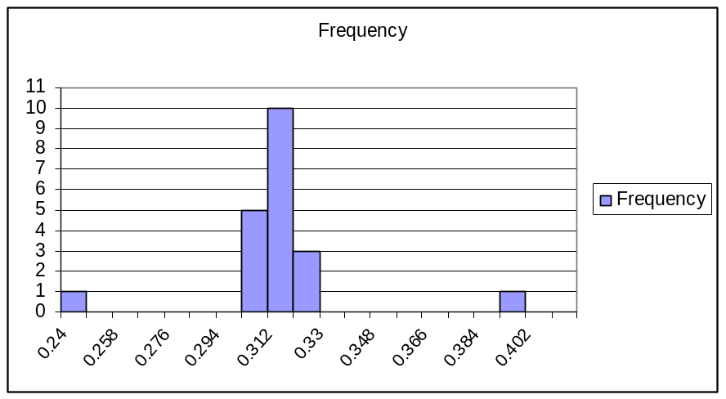
Bin | Frequency
0.24 | 1
0.249 | 0
0.258 | 0
0.267 | 0
0.276 | 0
0.285 | 0
0.294 | 0
0.303 | 5
0.312 | 10
0.321 | 3
0.33 | 0
0.339 | 0
0.348 | 0
0.357 | 0
0.366 | 0
0.375 | 0
0.384 | 0
0.393 | 1
0.402 | 0

Histograms – Lesson 2 Name ________________________
While performing a routine experiment, students gathered data for the time required for a muon to strike 2 detectors. The following data was collected and sorted:
Muon Speed Mode on: from channel 1 to 2 (dist 1.41m) |  |  |  | Time (ns)
1 |  | (1,2,-,-) | TOF | -8.25
2 |  | (1,2,-,-) | TOF | 0
3 |  | (1,2,-,-) | TOF | 1.5
4 |  | (1,2,-,-) | TOF | 1.5
5 |  | (1,2,-,-) | TOF | 1.5
6 |  | (1,2,-,-) | TOF | 1.5
7 |  | (1,2,-,-) | TOF | 2.25
8 |  | (1,2,-,-) | TOF | 2.25
9 |  | (1,2,-,-) | TOF | 2.25
10 |  | (1,2,-,-) | TOF | 3
11 |  | (1,2,-,-) | TOF | 3
12 |  | (1,2,-,-) | TOF | 3
13 |  | (1,2,-,-) | TOF | 3
14 |  | (1,2,-,-) | TOF | 3
15 |  | (1,2,-,-) | TOF | 3
16 |  | (1,2,-,-) | TOF | 3.75
17 |  | (1,2,-,-) | TOF | 3.75
18 |  | (1,2,-,-) | TOF | 3.75
19 |  | (1,2,-,-) | TOF | 3.75
20 |  | (1,2,-,-) | TOF | 3.75
21 |  | (1,2,-,-) | TOF | 4.5
22 |  | (1,2,-,-) | TOF | 4.5
23 |  | (1,2,-,-) | TOF | 4.5
24 |  | (1,2,-,-) | TOF | 4.5
25 |  | (-,2,-,-) | TOF | 4.5
26 |  | (1,2,-,-) | TOF | 4.5
27 |  | (1,2,-,-) | TOF | 4.5
28 |  | (1,2,-,-) | TOF | 5.25
29 |  | (1,2,-,-) | TOF | 5.25
30 |  | (1,2,-,-) | TOF | 5.25
31 |  | (1,2,-,-) | TOF | 5.25
32 |  | (1,2,-,-) | TOF | 5.25
33 |  | (1,2,-,-) | TOF | 5.25
34 |  | (1,2,-,-) | TOF | 5.25
35 |  | (1,2,-,-) | TOF | 6
36 |  | (1,2,-,-) | TOF | 6
37 |  | (1,2,-,-) | TOF | 6
38 |  | (1,2,-,-) | TOF | 6.75
39 |  | (1,2,-,-) | TOF | 7.5
40 |  | (1,2,-,-) | TOF | 8.25
Time range (nanoseconds) | # of values

- Do you see a pattern in the time data as it was recorded off of the detectors? What is it?

- Are there any values that appear to be ‘outlying’ data that can be removed prior to doing the histogram? Why would you exclude them?

- Now that the outlying numbers have been removed, determine the range of values, highest and lowest values for time in nanoseconds Highest _____________________ Lowest______________________
- Determine the bin ranges that will be used and complete the chart to the right, categorizing each time value into its proper range.
- On the graph paper, label the x-axis as time (seconds) and the y-axis as frequency.
- For each time range shade in the number of boxes (frequency) that correspond to the number of events that occurred within that range.
Teacher Answer Sheet - Histograms – Lesson 2
- The pattern of the recorded time data has 0.75 differences between recordings. This is due to the internal mechanism (resolution) of the boards to record in that time interval
- The outlying values of -8.25 and 8.25 could be removed prior to doing the histogram but it is important that the students know that the -8.25 is not being removed because it is negative… this leads to a good discussion of why negative numbers might appear and that it doesn’t necessarily mean that they need to be removed. The reason that these two values are removed is due to the fact that they are so far out of the range of the other values that they are probably due to some error.
Bin | 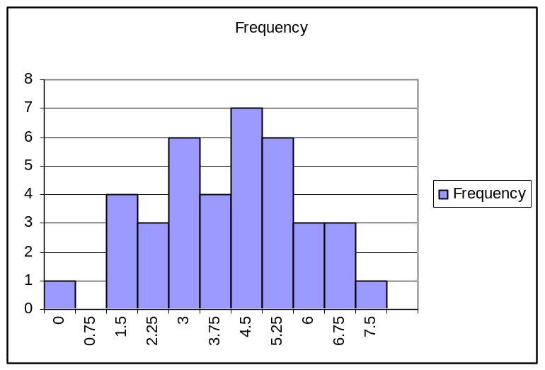  Frequency
0 | 1
0.75 | 0
1.5 | 4
2.25 | 3
3 | 6
3.75 | 4
4.5 | 7
5.25 | 6
6 | 3
6.75 | 3
7.5 | 1

A Question of Timing Name

People have been consumed by a fitness craze lately and it seems like everyone has taken up walking. To maximize the health benefits people are walking at the a brisk, constant rate.

A local physics teacher capitalizes on the trend and has assigned extra credit work to his top two students, Jane and Fred. Their task is to determine the average speed of a particularly enthusiastic walker, Mr. D. To determine Mr. D’s speed the students are given the following materials:
1. Stopwatches (2)
2. Metric measuring tape (1)

In the space provided explain a procedure the students could use to determine Mr. D’s average speed.

________________________________________________________________________________________________________________________________________________________________________________________________________________________

Pretty trivial you may think, but not so fast…

To make the task worthy of extra credit the teacher has programmed a constant error into Fred’s stopwatch so that it reads a little longer or shorter than it should!

As an example, consider a stopwatch that measures the time it takes a runner moving at 5 m/s to travel 10 meters.

- If the stopwatch works correctly it should read: | _______ seconds.
- If the stopwatch always adds 2.4 seconds to each measurement, then instead of reading the time above it will actually read: | _______ seconds.

THE GOALS:
Fred and Jane want to:
- Determine Mr. D’s average speed.
- Uncover the error programmed into the stopwatch.

Procedure:
Fred and Jane have marked off a starting line as well as a line at 12 meters and another at 24 meters. Each stands at the line as indicated and starts timing when Mr. D crosses the starting line and stops their clock as Mr. D passes their respective line.
Start
Fred
Jane

12 m
24 m

Mr. D. is very accommodating and gladly allows the team to time him for the following 10 trials.
Trial | Fred (12 m) | Jane (24 m) | Difference in Times
1 | 6.22 | 8.02
2 | 6.22 | 8.01 | How far did Mr. D travel in this time?  ANS: _____m
3 | 6.19 | 8.05
4 | 6.20 | 8.02
5 | 6.19 | 7.98
6 | 6.20 | 8.01
7 | 6.20 | 8.01
8 | 6.19 | 8.01
9 | 6.19 | 8.02
10 | 6.18 | 8.01
Averages

Jane suggests that she and Fred switch positions and repeat the experiment. Maybe she’s on to something… The new data is listed below.

Trial | Jane (12 m) | Fred (24 m) | Difference in Times
1 | 3.03 | 11.20
2 | 2.98 | 11.18 | Again, how far did Mr. D travel in this time?  ANS: _____m
3 | 3.04 | 11.19
4 | 3.03 | 11.20
5 | 3.01 | 11.17
6 | 2.99 | 11.20
7 | 2.99 | 11.23
8 | 2.99 | 11.19
9 | 3.03 | 11.19
10 | 3.01 | 11.19
Averages
Analysis:
As was the case with the example stopwatch, the ones used above can either add or subtract time from the true times. Determine what should be done to the data to answer the question and explain exactly what you did in the space below.

Explain why Jane’s idea to switch and retake data is so important. Can the problem be solved without doing this?

Conclusion

Calculate the actual average speed of Mr. D:

ANS _______ m/s.

The error programmed into the stopwatch for Fred, _______ seconds.

Soon we will be determining the average speed of a muon in lab. The experiment setup is very similar to the one used here to determine the average speed of the walker Mr. D. Like the stopwatches used in the experiment above, the timers inside the photo multiplier tube are subject to making errors as well. It’s up to us to determine what these errors are and calibrate our data accordingly. To determine the correct time of flight for the muon (and thus the correct speed), we will use a technique very similar to the one used above.

Histograms – Lesson 3 Name _______________________
While performing a routine experiment, students gathered data for the time required for a muon to strike 2 detectors. They then switched the order of the paddles and collected additional data. The data was collected and sorted into 2 tables. Your goal is to create 2 histograms of the data using an Excel spread sheet.
Data Analysis:
You will need to complete this analysis for each trial.
1. Copy and Paste the data from Trial 1 into an excel spread sheet. This data has already been sorted in ascending order. The column of particular interest contains the time (nanoseconds) – and will most likely be found in column E.
At this point, if you find any very large values for a time difference at the top or bottom of your column of time differences, there is some error in the measurement. These values can be eliminated from the histogram data.
2. In a blank column create bins that will contain the collected data. The bin sizes will be 0.75 nanoseconds. Be sure to take into account the negative numbers so that your numbers are centered about the number zero. (… -3, -2.25, -1.5, -0.75, 0, 0.75, 1.5, 2.25, 3 …). The bins are created in this fashion because 0.75 nanoseconds represent the smallest segment of time recorded by the computer. The largest negative and largest positive number in your sorted column of time differences will determine the minimum and maximum times and the number of bins required. Create a separate column entitled bin sizes.
4. Now create a histogram for your data (Tools-Data Analysis-Histogram). Under Tools there should be a Data Analysis program. If there is not, click on “Add-ins” and make sure the “Analysis tool pack” is checked (turned on). Now click on the Data Analysis program and then click on Histogram.
5. Click on the button for the “Input Range”. Now click on your first time difference cell (largest negative value) and drag to the last (most positive) cell. This will input all your time differences into the Input range. Hit enter to insert the data
6. Click on the button for “Bin Range” and drag from the first cell to the last cell of the bins that were created (Step 4). Hit enter to insert the data.
7. Lastly, click on OK in the final histogram box. You should see two highlighted columns labeled “bins” and “frequency” on a new sheet.

8. At this time you are ready to create a graph of the histogram data. With the two columns highlighted, click on the chart wizard icon on the tool bar.
9. Choose the “Column” bar graph.
10. Title this graph “Time of Flight”. The x-axis contains “Time Difference”. The y-axis contains “Number of Events”.
11. Repeat the process for Trial 2 data.
Muon Speed Mode on: from channel 1 to 2  (dist 1.41m) |  |  |  | Trial 1  nanoseconds
1 |  | (1,2,-,-) | TOF | -8.25
2 |  | (1,2,-,-) | TOF | 0
3 |  | (1,2,-,-) | TOF | 1.5
4 |  | (1,2,-,-) | TOF | 1.5
5 |  | (1,2,-,-) | TOF | 1.5
6 |  | (1,2,-,-) | TOF | 1.5
7 |  | (1,2,-,-) | TOF | 2.25
8 |  | (1,2,-,-) | TOF | 2.25
9 |  | (1,2,-,-) | TOF | 2.25
10 |  | (1,2,-,-) | TOF | 3
11 |  | (1,2,-,-) | TOF | 3
12 |  | (1,2,-,-) | TOF | 3
13 |  | (1,2,-,-) | TOF | 3
14 |  | (1,2,-,-) | TOF | 3
15 |  | (1,2,-,-) | TOF | 3
16 |  | (1,2,-,-) | TOF | 3.75
17 |  | (1,2,-,-) | TOF | 3.75
18 |  | (1,2,-,-) | TOF | 3.75
19 |  | (1,2,-,-) | TOF | 3.75
20 |  | (1,2,-,-) | TOF | 3.75
21 |  | (1,2,-,-) | TOF | 4.5
22 |  | (1,2,-,-) | TOF | 4.5
23 |  | (1,2,-,-) | TOF | 4.5
24 |  | (1,2,-,-) | TOF | 4.5
25 |  | (-,2,-,-) | TOF | 4.5
26 |  | (1,2,-,-) | TOF | 4.5
27 |  | (1,2,-,-) | TOF | 4.5
28 |  | (1,2,-,-) | TOF | 5.25
29 |  | (1,2,-,-) | TOF | 5.25
30 |  | (1,2,-,-) | TOF | 5.25
31 |  | (1,2,-,-) | TOF | 5.25
32 |  | (1,2,-,-) | TOF | 5.25
33 |  | (1,2,-,-) | TOF | 5.25
34 |  | (1,2,-,-) | TOF | 5.25
35 |  | (1,2,-,-) | TOF | 6
36 |  | (1,2,-,-) | TOF | 6
37 |  | (1,2,-,-) | TOF | 6
38 |  | (1,2,-,-) | TOF | 6.75
39 |  | (1,2,-,-) | TOF | 7.5
40 |  | (1,2,-,-) | TOF | 8.25
But Muon Speed Mode on:  from channel 1 to 2  (dist 1.41m) |  |  |  | Trial 2 nanoseconds
1 |  | (1,2,-,-) | TOF | -17.25
2 |  | (1,2,-,-) | TOF | -13.5
3 |  | (1,2,-,-) | TOF | -12
4 |  | (1,2,-,-) | TOF | -11.25
5 |  | (1,2,-,-) | TOF | -11.25
6 |  | (1,2,-,-) | TOF | -9.75
7 |  | (1,2,-,-) | TOF | -8.25
8 |  | (1,2,-,-) | TOF | -7.5
9 |  | (1,2,-,-) | TOF | -7.5
10 |  | (1,2,-,-) | TOF | -7.5
11 |  | (1,2,-,-) | TOF | -7.5
12 |  | (1,2,-,-) | TOF | -7.5
13 |  | (1,2,-,-) | TOF | -6.75
14 |  | (1,2,-,-) | TOF | -6.75
15 |  | (1,2,-,-) | TOF | -6.75
16 |  | (1,2,-,-) | TOF | -6.75
17 |  | (1,2,-,-) | TOF | -6.75
18 |  | (1,2,-,-) | TOF | -6.75
19 |  | (1,2,-,-) | TOF | -6
20 |  | (1,2,-,-) | TOF | -6
21 |  | (1,2,-,-) | TOF | -6
22 |  | (1,2,-,-) | TOF | -6
23 |  | (1,2,-,-) | TOF | -5.25
24 |  | (1,2,-,-) | TOF | -5.25
25 |  | (1,2,-,-) | TOF | -5.25
26 |  | (1,2,-,-) | TOF | -5.25
27 |  | (1,2,-,-) | TOF | -5.25
28 |  | (1,2,-,-) | TOF | -5.25
29 |  | (1,2,-,-) | TOF | -5.25
30 |  | (1,2,-,-) | TOF | -5.25
31 |  | (1,2,-,-) | TOF | -4.5
32 |  | (-,2,-,-) | TOF | -4.5
33 |  | (1,2,-,-) | TOF | -4.5
34 |  | (1,2,-,-) | TOF | -3.75
35 |  | (1,2,-,-) | TOF | -3.75
36 |  | (1,2,-,-) | TOF | -3.75
37 |  | (1,2,-,-) | TOF | -3.75
38 |  | (1,2,-,-) | TOF | -3.75
39 |  | (1,2,-,-) | TOF | -3.75
40 |  | (1,2,-,-) | TOF | -3.75
41 |  | (1,2,-,-) | TOF | -3
42 |  | (1,2,-,-) | TOF | -3
43 |  | (1,2,-,-) | TOF | -2.25
44 |  | (1,2,-,-) | TOF | -2.25
45 |  | (1,2,-,-) | TOF | -2.25
46 |  | (1,2,-,-) | TOF | -0.75
47 |  | (1,2,-,-) | TOF | 0

Analysis Questions

- How can you explain the difference in data values in Trail 1 and Trial 2?

- Looking at the 2 histograms, how do they differ, how are they alike?

- Use Excel to determine the average TOF (time of flight) for each trial. (The TOFs will become useful when you want to figure out the Speed of a Muon in the next exercise). You will determine the average by writing in a blank cell =average
and then drag the curser over the values in your time (ns) column. This should input all the values and calculate your average TOF.

Teacher answer sheet - Histograms – Lesson 3

- The students should realize that the data for trial 1 is predominantly positive and the data for Trial 2 is predominantly negative. This leads to the discussion of switching the position of the detectors and how the computer picks up the data being sent to it.
- Differences and similarities between the 2 histograms can be discussed.
- Average time of flight needs to be learned on Excel for data of this quantity. Students can determine the averages on their calculators if they are having trouble with Excel, but Excel is the preferred, and faster, method.

Bin | 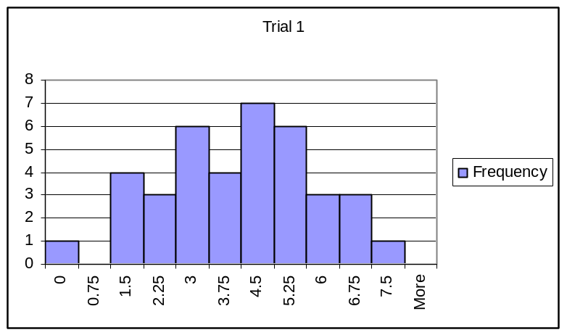  Frequency
0 | 1
0.75 | 0
1.5 | 4
2.25 | 3
3 | 6
3.75 | 4
4.5 | 7
5.25 | 6
6 | 3
6.75 | 3
7.5 | 1

Bin | 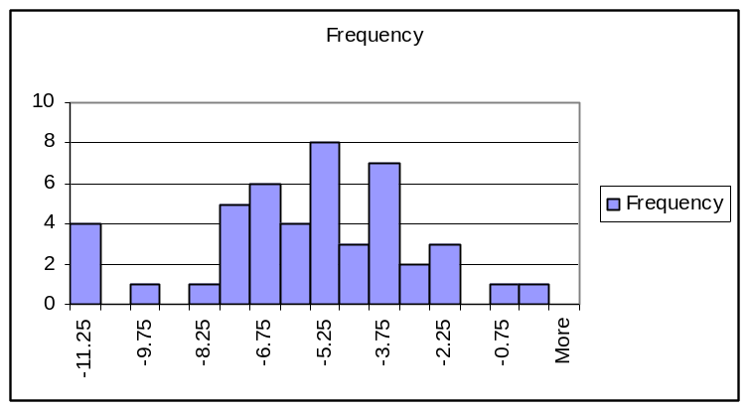  Frequency
-11.25 | 4
-10.5 | 0
-9.75 | 1
-9 | 0
-8.25 | 1
-7.5 | 5
-6.75 | 6
-6 | 4
-5.25 | 8
-4.5 | 3
-3.75 | 7
-3 | 2
-2.25 | 3
-1.5 | 0
-0.75 | 1
0 | 1

Average TOF:

Trail 1: 3.95 ns

Trial 2: -5.72 ns this value can be used as an absolute value of 5.72 ns. The negative on the original value is due to the reversed position of the detector and how the computer registered the order of the ‘hits’

NOTE: For future reference – using these two averages, the true TOF can be determined. Use the average TOFs from each trial and determine their average. (2.95 + 5.72)/2 = 4.34 ns. This time value removes the variation due to the ‘offsets’ in the computer receiving delayed input from the detectors.
The time and distance can then be used to determine the speed of the muon.
V = d/t
= 1.41 m / (4.34 x 10⁻⁹ s) = 3.25 x 10⁸ m/s
This answer should be very close to the speed of light…this data produced fairly good results – about 8% error.

Finding Muon Speed
Set-Up/Materials
1. Place two paddles separated vertically by approximately 1.4 meters. Connect the top paddle into channel 1 on your board and the bottom paddle into channel 2.
2. Measure the exact distance between your paddles.

Setting Up the Computer:
1. Open the data acquisition program on the computer by typing ./startDaq after the $
2. -Select choice (1) Set Control Register
-Select (a) Enable/Disable inputs and enter y for channels 1 and 2 and n for channels 3 and 4. (This will enable only channels 1 and 2.)
-Select (b) Set the coincidence level and enter 2 (This will require hits in both paddles 1 and 2.)
-Select (d) Return to main menu
3. -Select (7) Configure this program
-Select (m) Muon speed mode and enter y (yes) to measure the time of flight between two specific paddles. Select 1 for the first paddle and 2 for the second.
-Select (x) return to main menu
4. Select (6) modify data file name and name your file. If you want to look at the file later, it will be stored as muon.filename where filename is whatever you called this file.
5. Select (5) Begin Custom and enter the number of seconds over which you would like to take data. Ex. 5 or 10 minutes (But remember to enter your time in seconds.)
The computer should begin taking data right away although is may take a while before the first events show up on the screen.

Transferring Data:
1. Select (q) quit and the line ending with a $ should appear.
2. Insert a flash drive into the computer.
3. Type mount /mnt/usbflash
4. Type cp muon.filename /mnt/usbflash (using your previously selected file name). This will copy your file to the flash drive. If you cannot remember your filename, type ls and a list of the saved files will appear so that you can find your own. After you have copied your file, you may want to make sure it is on the flash drive. You can type ls /mnt/usbflash and this will list the files on the flash drive. Simply check to make sure your file is there.
5. Type umount /mnt/usbflash
6. Now you may remove the flash drive from the computer.
7. Put you flash drive into a computer that has Excel on it.
8. Open Excel and then open your file. If the Test Import Wizard appears, select Finish at the bottom right side of the window. Your data should appear separated into columns and you are now ready for data analysis.
Switching positions to determine Speed of a Muon
1. Repeat the experiment by changing the position of the paddles.
2. Determine the average TOFs for each of the trials after removing the ‘outlying’ values.
3. Take the average of the 2 TOF averages to make the correction for the time delay of the computer.
4. Use the time value you get in #3 and the exact distance between the detectors to determine the speed of a muon.
5. Determine your % error using the speed of light as the accepted value.

Data Analysis using Histograms
You will need to complete this analysis for each trial you run.
1. The column of particular interest is column E.
2. Sort the data (Data-Sort-column E-Ascending) so that the time differences are from least to greatest. You will now put this data into bins so that a histogram of the data can be created.
3. In a blank column create bins that will contain the collected data. The bin sizes will be 0.75 nanoseconds centered about the number zero(….. -3, -2.25, -1.5, -0.75, 0, 0.75, 1.5, 2.25 …….). The bins are created in this fashion because 0.75 of a nanosecond represents the smallest segment of time recorded by the computer. The largest negative and largest positive number in your sorted column of time differences will determine the minimum and maximum times and the number of bins required. Create a separate column entitled bin sizes.
4. Now create a histogram for your data (Tools-Data Analysis-Histogram). Under Tools there should be a Data Analysis program. If there is not, click on “Add-ins” and make sure the “Analysis tool pack” is checked (turned on). Now click on the Data Analysis program and then click on Histogram.

5. Click on the button for the “Input Range”. Now click on your first time difference cell (largest negative value) and drag to the last (most positive) cell. This will input all your time differences into the Input range. Hit enter to insert the data. [At this point, if you find any very large values for a time difference at the top or bottom of your column of time differences, there is some error in the measurement. These values can be eliminated from the histogram data because they may not be identified as a coincidence (column C) but as a single paddle strike.]
6. Click on the button for “Bin Range” and drag from the first cell to the last cell of the bins that were created (Step 4). Hit enter to insert the data.
7. Lastly, click on OK in the final histogram box. You should see two highlighted columns labeled “bins” and “frequency” on a new sheet.
8. At this time you are ready to create a graph of the histogram data. With the two columns highlighted, click on the chart wizard icon on the tool bar.
9. Choose the “Column” bar graph.
10. Title this graph “Time of Flight”. The x-axis contains “Time Difference”. The y-axis contains “Number of Events”.

Advanced level analysis
11. Now you need to determine the mode of the data. Return to your data page. The largest peak on the histogram should represent this. For accuracy purposes use the statistics function available. Click on a blank cell on the original sheet and choose (Insert-Function) from the tool bar.
12. In the “Paste Function” box choose “Statistical” as the function category and “Mode” as the function name. Click OK.
13. Click and drag on all the cells in the time difference column and push enter. The number that appears in the cell is the mode of the data.
14. Now determine the standard deviation of the collected data. To do this, once again click on a blank cell and from the tool bar choose Insert-Function-Statistical- STDEV. Again, click and drag on the time difference column and push OK. The number appearing in the cell is the standard deviation of the data.
15. You will use the mode and standard deviation to eliminate data points that have a high probability of occurring by chance. To do this, find the range of time differences about the mode that encompasses three standard deviations in both directions. For example, if your mode is 4.0 and the standard deviation is 1.0 the range of time differences will be 3.0 to 5.0 (4.0 - 1.0 = 3.0 and 4.0 + 1.0 = 5.0).
16. Now, calculate the average time difference within this range. Insert-Function-Statistical-AVERAGE. This time however, only click and drag on the values that fall within the time difference range that was just calculated. This is now the average time of travel between the two paddles for the collected data.

17. Determine the uncertainty in this value by dividing the standard deviation by the square root of the number of events.

18. Follow the above instructions for both trials when the paddles are separated a large distance and when they are close together.
19. Calculate the distance by subtracting the smaller distance from the larger distance.
20. Calculate the time by subtracting the smaller average time difference from the larger average time difference.
21. Estimate the uncertainty in each distance measurement (approximately 1-2 mm).

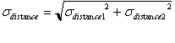
22. Determine the uncertainty in the calculated distance measurement by taking the square root of the sum of the squares of the individual uncertainties.

23. Determine the uncertainty in the time by taking the square root of the sum of the squares of the individual uncertainties.
The

24. Calculate the average speed of muons by dividing the distance by the time.

25. Determine the uncertainty of the average speed of the muons by using the following equation:
(σ_{v}/v)² = (σ_{d}/d)² + (σ_{t}/t)²

